Student Assessment Submission and Declaration

When submitting evidence for assessment, each student must sign a declaration confirming that the work is their own.

|  |  |  |  |
| --- | --- | --- | --- |
| Student name:  Rashed Hassan Qahah.  21026420 | | Assessor name:  Khalil Saleh | |
| Issue date:  25/4/2022 | Submission date:  25/5/2022 | | Submitted on: |
| Programme: | | | |
| Unit: 2 | | | |
| Assignment | | | |

**TASK A:**

**1- Negotiate and list the used network types in the whole design, and determine the number of each type, after that specify and explain the network types.**

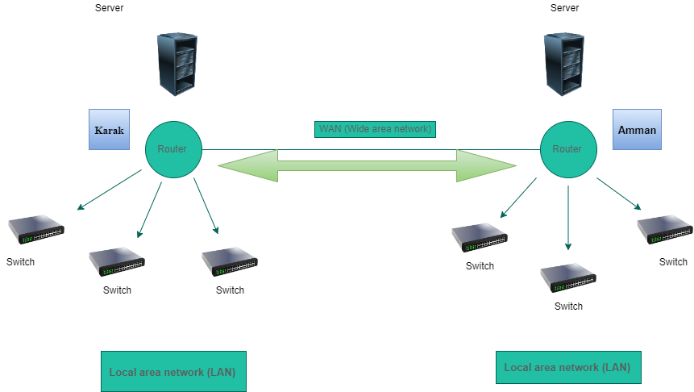**Answer:**

Number of networks:

7 Networks.

Existing networks in the figure above:

1- LAN (Local area network).

The type of network used between the server and the switch is LAN.

2- WAN (Wide area network).

The type of network used between the server Amman and the server Karak is WAN.

Types of networks:

1- Local area network (LAN) - usually contained in a small space Such as an office, building or home.

A local area network (LAN) is made up of a group of computers that are linked together to form a network in a specific location. A LAN's computers communicate with one another via TCP/IP ethernet or Wi-Fi. A LAN is typically restricted to a single organization, such as an office, organization.

2- WAN (Wide area network) - a group of LANs that spread over a wide geographical area Internet is the largest and most varied.

A wide area network (WAN) is a huge information network that is not restricted to a single location. Through a WAN provider, WANs can facilitate communication, information sharing, and much more between devices all over the world.

3- Metropolitan area network (MAN) - a group of connected LANs in the same geographical area Also known as a campus area network (CAN).

which can be a single large city, a group of cities and towns, or any given large area with multiple buildings. A MAN is larger than a LAN but smaller than a wide area network (WAN) (WAN). MANs are not required to be located in urban areas; the term "Metropolitan" refers to the size of the network, not the demographics of the area served.

4- PAN (Personal area network) - smallest network A network of personal devices.

A personal area network (PAN) is a network that connects electronic devices in a user's immediate vicinity. A PAN can range in size from a few centimetres to a few meters. The connection between a Bluetooth earpiece and a smartphone is one of the most common real-world examples of a PAN. Laptops, tablets, printers, keyboards, and other computerized devices can also be connected via PANs.

**2- Consider the network standards to explain the standards required in your design.**

**Answer:**

- Ethernet standard used with twisted pair cabling.

|  |  |  |  |  |  |
| --- | --- | --- | --- | --- | --- |
| Standard | Maximum transmission speed - Mbps. | Maximum distance  Per segments - M. | Physical media. | Pairs of wires used for transmission. |  |
| 10 Base – T  Regular Ethernet | 10 | 100 | Cat 3 or better UTP | 2 pair |  |
| 100 Base -T  Fast Ethernet | 100 | 100 | Cat 5 or better UTP | 2 pair |  |
| 1000 Base – T  Gigabit Ethernet | 1000 | 100 | Cat 5 or better  UTP | 4 pair |  |
| 1000 Base – TX | 1000 | 100 | Cat 6 | 2 pair |  |
| 10G Base – T  10 – Gigabit | 10,000 | 100 | Cat 6a or Cat 7  (Cat 7 is Preferred) |  |  |

* The newer the category, the faster data transfer speed.
* The type of Cable used is Cat 6 || Twisted – Pair Cabling.
* Cat 6 Ethernet cables can be run outdoors to network computers with a local area network (LAN) between homes or other buildings.
* Ethernet standards using Fiber – optic cable

|  |  |  |  |
| --- | --- | --- | --- |
| Physical media. | Maximum distance per segment – M | Maximum transmission speed – Maps | Standard |
| MMF | 412 for half – duplex.  2000 for full – duplex. | 100 | 100 Base – FX Fast Ethernet. |
| MMF or SMF | 550 for MMG.  5000 for SMF. | 1000 | 1000 Base – LX  Gigabit Ethernet. |
| MMF | Up to 550, depending on modal bandwidth and fiber core diameter. | 1000 | 1000 Base – SX  Gigabit Ethernet. |
| MMF | Up to 300, depending on modal bandwidth and fiber core diameter. | 10,000 | 10G Base – SR and  10G Base – SW  10 – Gigabit Ethernet. |
| SMF | 10,000 | 10,000 | 10G Base – LR and  10G Base – LW  10 – Gigabit Ethernet. |
| SMF | 40,000 | 10,000 | 10G Base – ER and  10G Base – EW  10 – Gigabit Ethernet. |

- The type of Cable used is

10G Base – ER and

10G Base – EW

10 – Gigabit Ethernet.

**IP address:**

* IP addresses are assigned to each network node It is used by the network layer to uniquely identify each host.
* IP adds the segment's or datagram's network layer address.
* Used by the network layer to uniquely identify each host.
* IP needs to rely on many routing protocols, such as ICMP and ARP, to determine the best path for the package to take to reach its destination.
* IP addresses are the identifiers that allow information to be sent between devices on a network they include location information and allow devices to communicate with one another.
* The internet requires a identify to distinguish between different computers routers and websites.
* IP addresses provide a means of doing so and are an essential component of how the internet operates.

**Transport layer:**

* Responsible for transporting Application.
* layer payloads from one application to another.

**Two main Transport layer protocols are:**

* TCP (Transmission Control Protocol) - A connection-oriented protocol establishes a connection with the end host and checks to see if data has been received.
* TCP (The Transmission Control Protocol) is a networking standard that specifies how to establish and maintain a network conversation in which applications can exchange data. TCP interacts with the Internet Protocol (IP), which defines how computers send data packets to one another.
* UDP (User Datagram Protocol):
* A connectionless protocol does not guarantee delivery by first connecting and checking whether data is received.
* UDP (User Datagram Protocol) is a communications protocol that is primarily used to establish low-latency and loss-tolerant connections between internet-connected applications. UDP speeds up transmissions by allowing data to be transferred before the receiving party provides an agreement

**3- Specify the network topologies in general.**

**Answer:**

- Topology: how parts of a whole work together.

- Topology is divided into two parts:

1- Physical topology - primarily applies to hardware and describes how computers, other devices, and cables connect to form the physical network.

2- Logical topology relates to software and describes how network access is controlled

How users and programs first gain network access.

The arrangement of a network's links and nodes in relation to one another is referred to as network topology. Topologies are classified as either physical network topology, which refers to the physical signal transmission medium, or logical network topology, which refers to the way data travels through the network between devices regardless of their physical connection. Twisted pair Ethernet, which is classified as a logical bus topology, and token ring, which is classified as a logical ring topology, are two examples of logical network topologies. Examples of physical network topologies include star, mesh, tree, ring, point-to-point, circular, hybrid, and bus topologies, which each have different node and link layouts. The ideal network topology is determined by the size, scale, and goals of each business, as well as budget A network topology diagram depicts the communicating devices, which are represented as nodes, as well as the connections between the devices, which are represented as links between the nodes.

A topology is basically a map of a network. The physical topology of a network describes the layout of the cables and workstations (Nodes) and the location of all network components. Often, physical topologies are compared to logical topologies, which define how the information or data flows within the network. Some of the common topologies are:

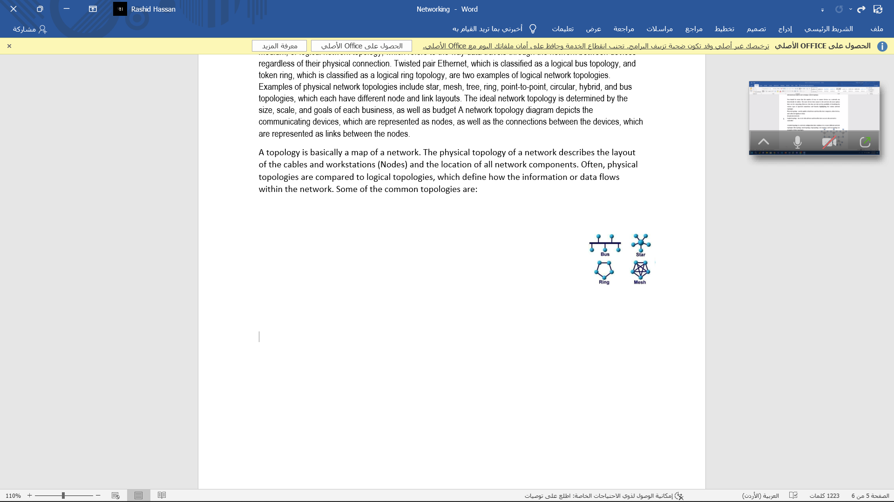1. Star

2. Ring

3. Bus

4. Mesh

Star Topology: Is one in which all microcomputers and other communications devices are connected to a central hub, such as file server or host computer. The advantages of a star network are: Simplicity and no collisions between messages. And you can disconnect any computer without stopping the network. if a failure occurs along one of the cables connecting to the hub, only that portion of the network is affected, not the entire network, but if the main hub is broken, the entire network stops working.

Bus Topology: All communications devices are connected to a common channel. Extra circuitry and software are needed to avoid collisions between data. If the main connection is broken, the entire network may stop working.

Ring Topology: Is one in which all microcomputers and other communications devices are connected in a continuous loop. Electronic messages are passed around the ring until they reach the right destination. The advantage of a ring network is that messages flow in only one direction. Thus, there is no danger of collisions. The disadvantage is if a connection is broken between any two communications devices, it will create a problem for the entire network.

Mesh Topology: In a mesh topology, a path exists from each station to every other station in the network. A mesh topology can become quite complex as wiring and connections increase exponentially. It can become expensive. The mesh topology is rarely used, and then only in a WAN environment and only because the mesh topology is fault tolerant. Computers or network devices can switch between these multiple, redundant connections.

**4- Differentiate the protocols used for the network transmission between switches and routers, consider the OSI model (IP, Ethernet protocols).**

**Answer:**

- The switch is a layer 2 and is responsible for the MAC (Media Access Control) Address, and through it as much I can select any device within the network.

- The router is a layer 3 and deals with the IP address, and is responsible for the device on any existing network.

5- Assess the used topology to connect the LAN switches with the Router according to the bandwidth requirements.

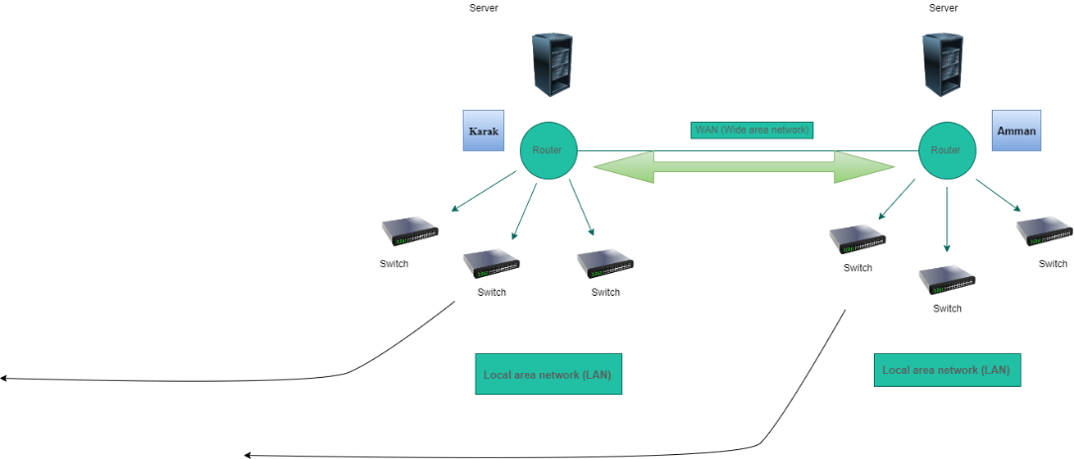

I want to use star Topology.

I want to use star Topology.

I have chosen and used the star topology in the LAN that is based in AMMAN the main branch.

The Benefits of Star Topology:

It is extremely dependable; if one cable or device fails, the others will continue to function normally.

It is fast because no data collisions can occur.

Less expensive because each device only requires one I/O port and wishes to be linked to a hub via a single link.

It's easier to install.

I have chosen and used the star topology in the LAN that is based in KARAK branch. for the same reason being the Benefits of Star Topology:

It is extremely dependable; if one cable or device fails, the others will continue to function normally.

It is fast because no data collisions can occur.

Less expensive because each device only requires one I/O port and wishes to be linked to a hub via a single link.

It's easier to install.

**TASK B:**

**1- Consider the necessary devices for this network and the principle of their work. Also, examine the required server types.**

**Answer:**

The necessary devices that will be placed in the Amman branch:

1- Router: A router is a device that manages traffic between two or more networks and can assist in determining the best path for traffic to take from one network to another.

2- Switch: receives data from one of its ports and routes it to another or multiple ports.

will deliver the data to its intended recipient.

3- PC: A personal computer is a multi-purpose microcomputer whose size, capabilities, and cost make it suitable for home use.

Personal computers are designed to be used by end users rather than computer experts or technicians.

4- Server: A server is a computer program or device that provides a service to another computer program and its user, who is referred to as the client. A server is a physical computer in a data center that runs a server program.

5- DNS Server: A Domain Name System is the phone book for the Internet. When users enter domain names such as google.com or chrome.com into web browsers, DNS is responsible for determining the correct IP address for all those websites. Browsers then use the addresses to communicate with origin servers or CDN edge servers to access website information. DNS servers, which are computers dedicated to answering DNS queries, make this all possible.

6- DHCP Server: Dynamic Host Configuration Protocol is a network management protocol that automates the process of configuring devices on IP networks, allowing them to use network services such as DNS, NTP, and any UDP or TCP-based communication protocol. A DHCP server assigns Ip Addresses Ip and other network configuration parameters to each device on a network in order for them to communicate with other IP networks. DHCP is an improved version of an older protocol known as BOOTP.

**2- Negotiate briefly how DHCP and DNS can help to improve network infrastructure?**

**Answer:**

The DNS functions and benefits:

In general, DNS is the only system in the world that can assist you in browsing the internet. With the internet becoming an increasingly important part of society, it is becoming increasingly important that DNS Servers are kept up to date. The web will not exist without them.

There is no need to memorize IP addresses because DNS servers provide a handy solution for converting domain or subdomain names to IP addresses. Consider how it would feel to have to memorize the IP addresses of Twitter, Facebook, Google, or any other website that you visit on a daily basis. It would undoubtedly be horrifying. Its system also makes it simple for search engines to categorize and archive data.

DNS servers are an important component for the security of your home or office connections. DNS servers designed for security typically ensure that attempts to hack your server environment are thwarted before gaining access to your machines. It is important to note, however, that the word used has been enhanced. This means that you'll need to implement additional security measures to protect your data, especially if you're a large organization with a lot of sensitive data.

DNS servers have fast internet connections -People and organizations who use DNS servers can benefit from high connection speeds, which are a key feature in some of these servers.

The following benefits are provided by DHCP:

Configuration of a dependable IP address. DHCP reduces manual IP address configuration errors, such as typographical errors, and address conflicts caused by assigning an IP address to more than one computer at the same time.

Network administration has been simplified. To reduce network administration, DHCP includes the following features:

TCP/IP configuration is centralized and automated.

The ability to define TCP/IP configurations from a single point of contact.

The ability to use DHCP to assign a wide range of additional TCP/IP configuration values.

The efficient handling of IP address changes for clients that need to be updated frequently, such as portable devices that move around a wireless network.

The use of a DHCP relay agent to forward initial DHCP messages, that also eliminates the requirement for a DHCP server on each subnet.

**3- Examine the required server types for best performance and cost effectiveness.**

**Answer:**

Hint: Most of efficient networks relies on domain concepts, file sharing and resource sharing and user permissions.

Answer: What types of servers will we need?

1- Web service.

2- Email service.

3- FTP service.

4- Telnet service.

5- Remote Desktop.

6- Remote applications.

TASK C:

**1- Formulate and perform the specified network system in Amman branch**

**And consider that each LAN has 3 hosts only (for demonstration).**

**2- Install and configure the DHCP service on the branch router.**

**3- Assess and check your design, document how your design meets the requirements.**

**Answer:**

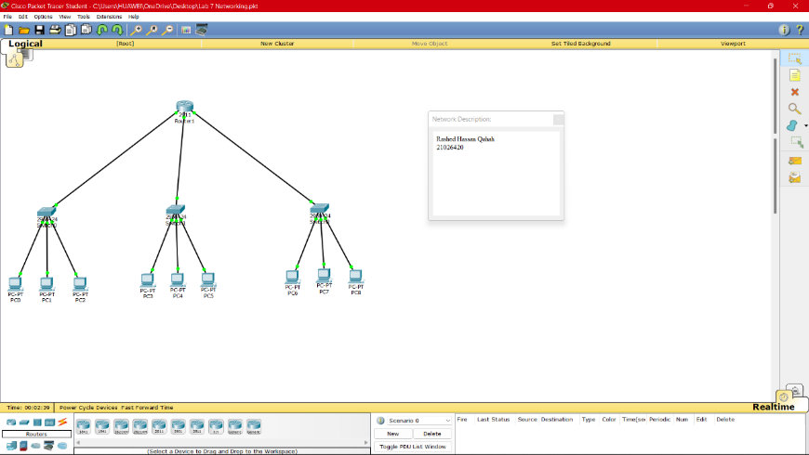

1-

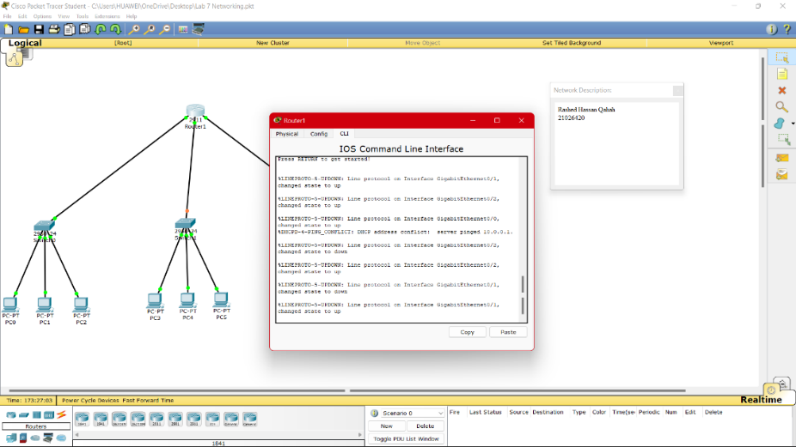2-

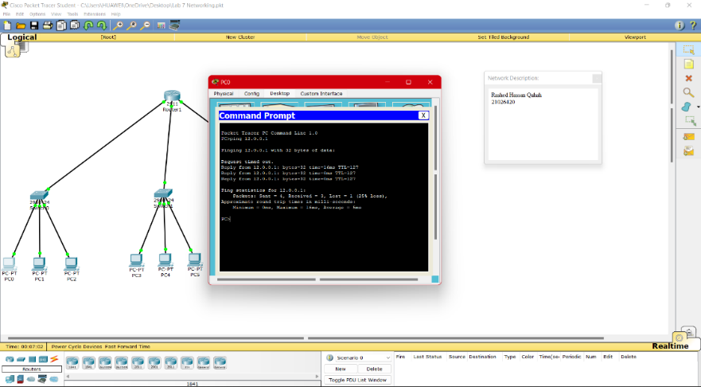

3-

**4- Suggest possible enhancements for the networked systems.**

**Answer:**

I will put a UPS system because it works on A UPS is typically used to protect hardware such as servers, workstations, telecommunications equipment, and other electrical equipment from a power outage, such as a power source failure or voltage spike. A UPS, on the other hand, is not a power strip, which is simply a device that allows you to plug in multiple electronic devices and provides minimal surge protection, and should not be confused with one. A UPS also provides more protection than a basic surge protector, which many businesses use as an additional layer of protection against power fluctuations.

Lieberman Technologies has UPSs for servers and desk locations, which protect workstations, phones, printers, and any other device that may be connected. UPSs offer far superior surge protection than standard surge protectors. They also offer power line conditioning, which is an adjustment of the power output to keep it consistent when the incoming power is either low (lag) or high (spike), as was done during the lightning strike. The power surge caused by the strike was followed by a brief power outage, and the UPSs protected our equipment from the damaging effects of such a severe power fluctuation. During this event, the UPS units also provided power backup. Several UPSs come with a USB/Serial connection to the PC or server, as well as software that allows for a "graceful" shutdown of the server or workstation, rather than an abrupt power off, which can frequently lead to software corruption We were able to keep our working data and did not suffer any productivity loss in the days that followed.

**5- Formulate a maintenance schedule to support the networked system.**

**Answer:**

Servers and networks require regular maintenance.

If servers and network infrastructure are essential to running your business, it is critical that you hire the right engineers to help you avoid service outages, and the actions I will take for regular maintenance are divided into three phases:

The first stage, what are the procedures and examinations that will be held on a daily basis:

Carry out energy source checks every day.

Ensure and perform backups on a daily basis to prevent complete data loss, it is better to have a good backup strategy than to need it and not have it. Select a full day to check server backups. Alternately, copy the server environment to a cloud virtual machine and test it on a regular basis.

Inspect air-conditioning systems and devices for devices on a daily basis so that in the absence of air-conditioning and refrigeration systems or in the event of their failure, a high temperature of servers and other devices may occur, causing network outages and the loss of information and data must be provided, as well as server racks.

Examine, improve or modify network security on a daily basis to meet customer needs.

The firewall device must be checked on a daily basis. A firewall is a type of network security device that monitors incoming and outgoing network traffic and allows or rejects data packets based on a set of security rules. Its purpose is to create a barrier between your internal network and traffic from external sources (such as the Internet) in order to block malicious traffic such as viruses and hackers.

The second stage, what are the procedures and examinations that will be held on a weekly basis:

Checking each piece individually every week for hardware faults.

Update network security software and hardware on a weekly basis.

Ensure that data and information are stored and reviewed on a weekly basis.

The third stage, what are the procedures and examinations that will be held on a monthly basis:

Checking critical vulnerabilities in the operating system on a monthly basis that require updates and patches.

Upgrade any necessary components that are outdated or need updating every month.

All these procedures and devices should be checked periodically as they contribute to the successful and smooth operation of your company's servers and networks.

There are many issues that can arise, and in the event of network security breaches, this can lead to devastating business consequences that may eventually destroy your reputation and lead to serious fines that may result in your company being permanently out of business. Keeping your servers and hardware in good working order is one of your top priorities which should be checked periodically.

**6- Recognise you design considering the VLAN and subnetting:**

**Answer:**

It was not used in VLAN because it has negatives and an illusion VLAN disadvantages.

Here are the main disadvantages and disadvantages of VLAN:

- A packet can be transferred from one VLAN to another.

- An injected packet could result in a cyber-attack.

- A single threat in a single system can spread a virus across an entire logical network.

- In large networks, an additional router is required to control the workload.

- Interoperability issues may arise.

- A VLAN cannot send network traffic to another VLAN.

It was not used in "Subnetting" because it has negatives of Subnetting To communicate with each other, different subnets require an intermediate device known as a router. Because each subnet has its own network address and broadcast address, having more subnets means wasting more IP addresses. Subnetting increases network complexity.

**Reference:**

www.efficientip.com/what-is-dhcp-and-why-is-it-important/.

<https://en.wikipedia.org/wiki/Personal_computer>.

https://www.heavy.ai/technical-glossary/network-topology.

**Plagiarism**

Plagiarism is a particular form of cheating. Plagiarism must be avoided at all costs and students who break the rules, however innocently, may be penalised. It is your responsibility to ensure that you understand correct referencing practices. As a university level student, you are expected to use appropriate references throughout and keep carefully detailed notes of all your sources of materials for material you have used in your work, including any material downloaded from the Internet. Please consult the relevant unit lecturer or your course tutor if you need any further advice.

**Student Declaration**

|  |
| --- |
| Student declaration  I certify that the assignment submission is entirely my own work and I fully understand the consequences of plagiarism. I understand that making a false declaration is a form of malpractice.  Student signature: Rashed Hasan Date: |